NEW TRANSMISSION FACILITIES ENABLE IMPROVED RECEPTION FOR HAMDEN CT LISTENERS OF WJMJ

Wednesday, November 21, 2012

Prospect, CT: WJMJ FM, the Archdiocesan radio station improved its signal quality on November 21, 2012 for listeners in the Hamden, CT area. New transmission equipment was put into place at the new transmission site in Hamden, replacing the 30 year old site on Booth Terrace in Hamden. The new site off Gaylord Mountain Road in Hamden will give better height and improved facilities enabling better reception and service to those WJMJ listeners in Hamden at 93.1 Mhz FM. WJMJ’s main signal is transmitted on 88.9Mhz reaching the Hartford metro area and Western Massachusetts. A third translator in New Haven at 107.1 Mhz FM reaches listeners in the greater New Haven area.

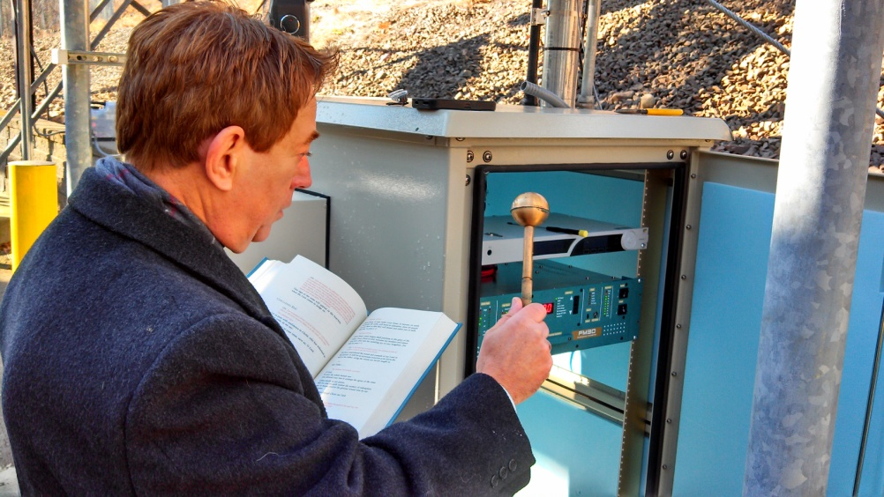

Fr. John Gatzak, Director of Radio & Television for the Archdiocese of Hartford and General Manager of WJMJ blessed the Hamden transmission equipment in a dedication service on November 21, 2012, saying *“Lord, give voice to your Church and enable your message to be heard and seen in the hearts of all taking us from the analog world, through the digital world to the world beyond – to your Kingdom. Let radio station WJMJ carry messages of aid in times of crisis, of solace in times of distress, of advice in times of doubt, of light in times of darkness. Lord, bless this translator, all of its equipment and all of us, your people of faith…help us to inspire and heal, uplift and support, inform and infuse your love, all in the name of the Father and of the Son and of the Holy Spirit. Amen.”*